“Sugato Weighted Long-Short Dow Trading Strategy”

Consider a daily portfolio of 6 Dow Stocks, s[1] thru s[6].

We have 6 weights, w[1] thru w[6]

Constraint on weight: Must be one of {0.05,0.1,0.15,0.2 ,…, 0.85,0.9,0.95}

(Diversification constraint: Weight can’t be 0 or 1)

Constraint on weight: w[1] + w[2] + w[3] = 1

Constraint on weight: w[4] + w[5] + w[6] = 1

Strategy: Sort yesterday’s returns.

s[1] thru s[3] = Yesterday’s 3 worst performing stocks

s[4] thru s[6] = Yesterday’s 3 best performing stocks

Go long s[1] thru s[3] :

LR = Long Return = s[1]\*w[1] + s[2]\*w[2] + s[3]\*w[3]

Short s[4] thru s[6] :

SR = Short Return = - (s[4]\*w[4] + s[5]\*w[5] + s[6]\*w[6])

Close out stocks at end of day.

Total Daily Return = LR + SR

Q1. How many such {w[1], w[2],w[3],w[4],w[5],w[6]} tuples overall ?

Ans. 29241

Q2. What do the best possible tuples return PER MONTH ?

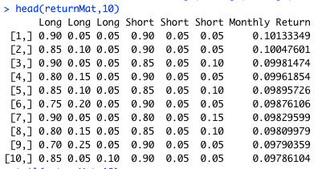

E.g. see[6] : Buy (75%, 20%,5%) of yesterday’s 3 worst performing stocks. Sell (90%,5%,5%) of yesterday’s 3 best performing stocks. Hold until end of day & close out. 9.87% monthly return.

Q3. What do the worst possible tuples return PER MONTH ?

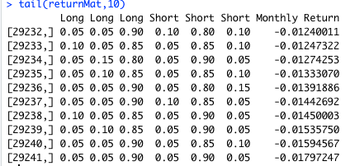

E.g. Buy (5%, 5%,90%) of yesterday’s 3 worst performing stocks. Sell (5%,85%,10%) of yesterday’s 3 best performing stocks. Hold until end of day & close out. -1.59% monthly return.

Q4. Sample Size?

N = 221 (There are 221 possible consecutive 30-day periods in 2018)

So we have 29241 tuples for each of the 221 possible months.

Q5. Return Distribution?

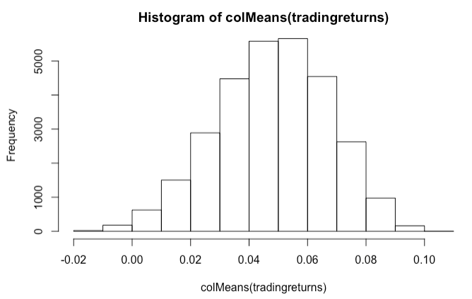

Positive skew, averaging around 5% a month.

Q6. Advantage over equal-weighted?

An (almost) equal weighting of (30%,35%,35%) long & (30%,35%,35%) short portfolio nets 4.49% monthly. Finding the optimal tuple gets us 2.06x i.e. over twice the return we would have obtained otherwise.